**Assignment 4 documentation**

**Ting Yan**

**010765513**

**Design decisions:**

In this project, I made a multiplayer extension to the bomberman game. I removed the player from the Game class and made multiplayersystem class that extends gameSystem. I created server thread and client thread in multiplayersystem. And also add player and the characters in multiplayersystem.

I also add thread class -client thread, server thread, and listener thread to receive and send input signals to synchronize events.

**Implementation process**

After reviewing ping project posted, I got a basic idea how to implementate the project. I first implement multiplayer system and established client and server and add characters and board. Then I finished thread class to establish a connection between a server and a client and send message. Lastly, I change the player class control listerner function, make it also sends gamestateEvent to its listeners in order to synchronize.

**Problems:**

Before reviewing ping project, I had no idea how to implement this project. This project is difficult since it combines server-client, parallel programming and event driven programming. After trying to adjust the code and test as I go, it worked well. But I used TCP for this project, if I can implement it with UDP sockets, it would be better for the game.

**Results:**

To run the project, first compile all the src file. After compiling, run server.class and then open client.class(you can open up to 3 clients).

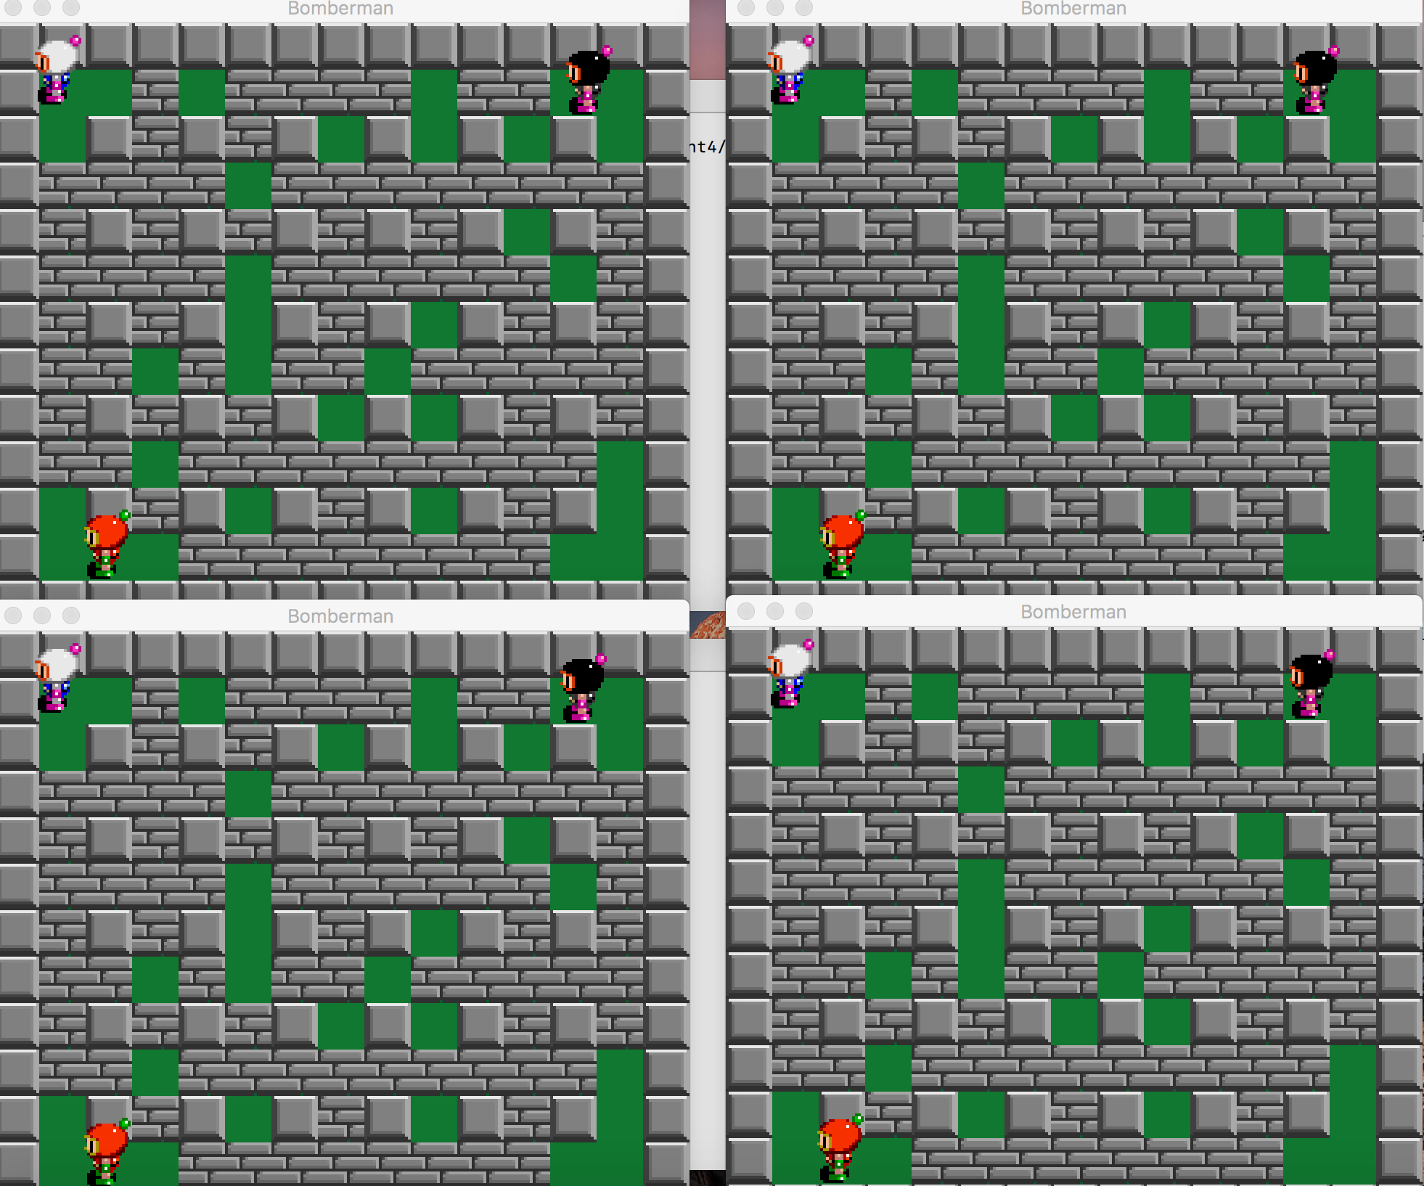

**players can move and throw bomb**

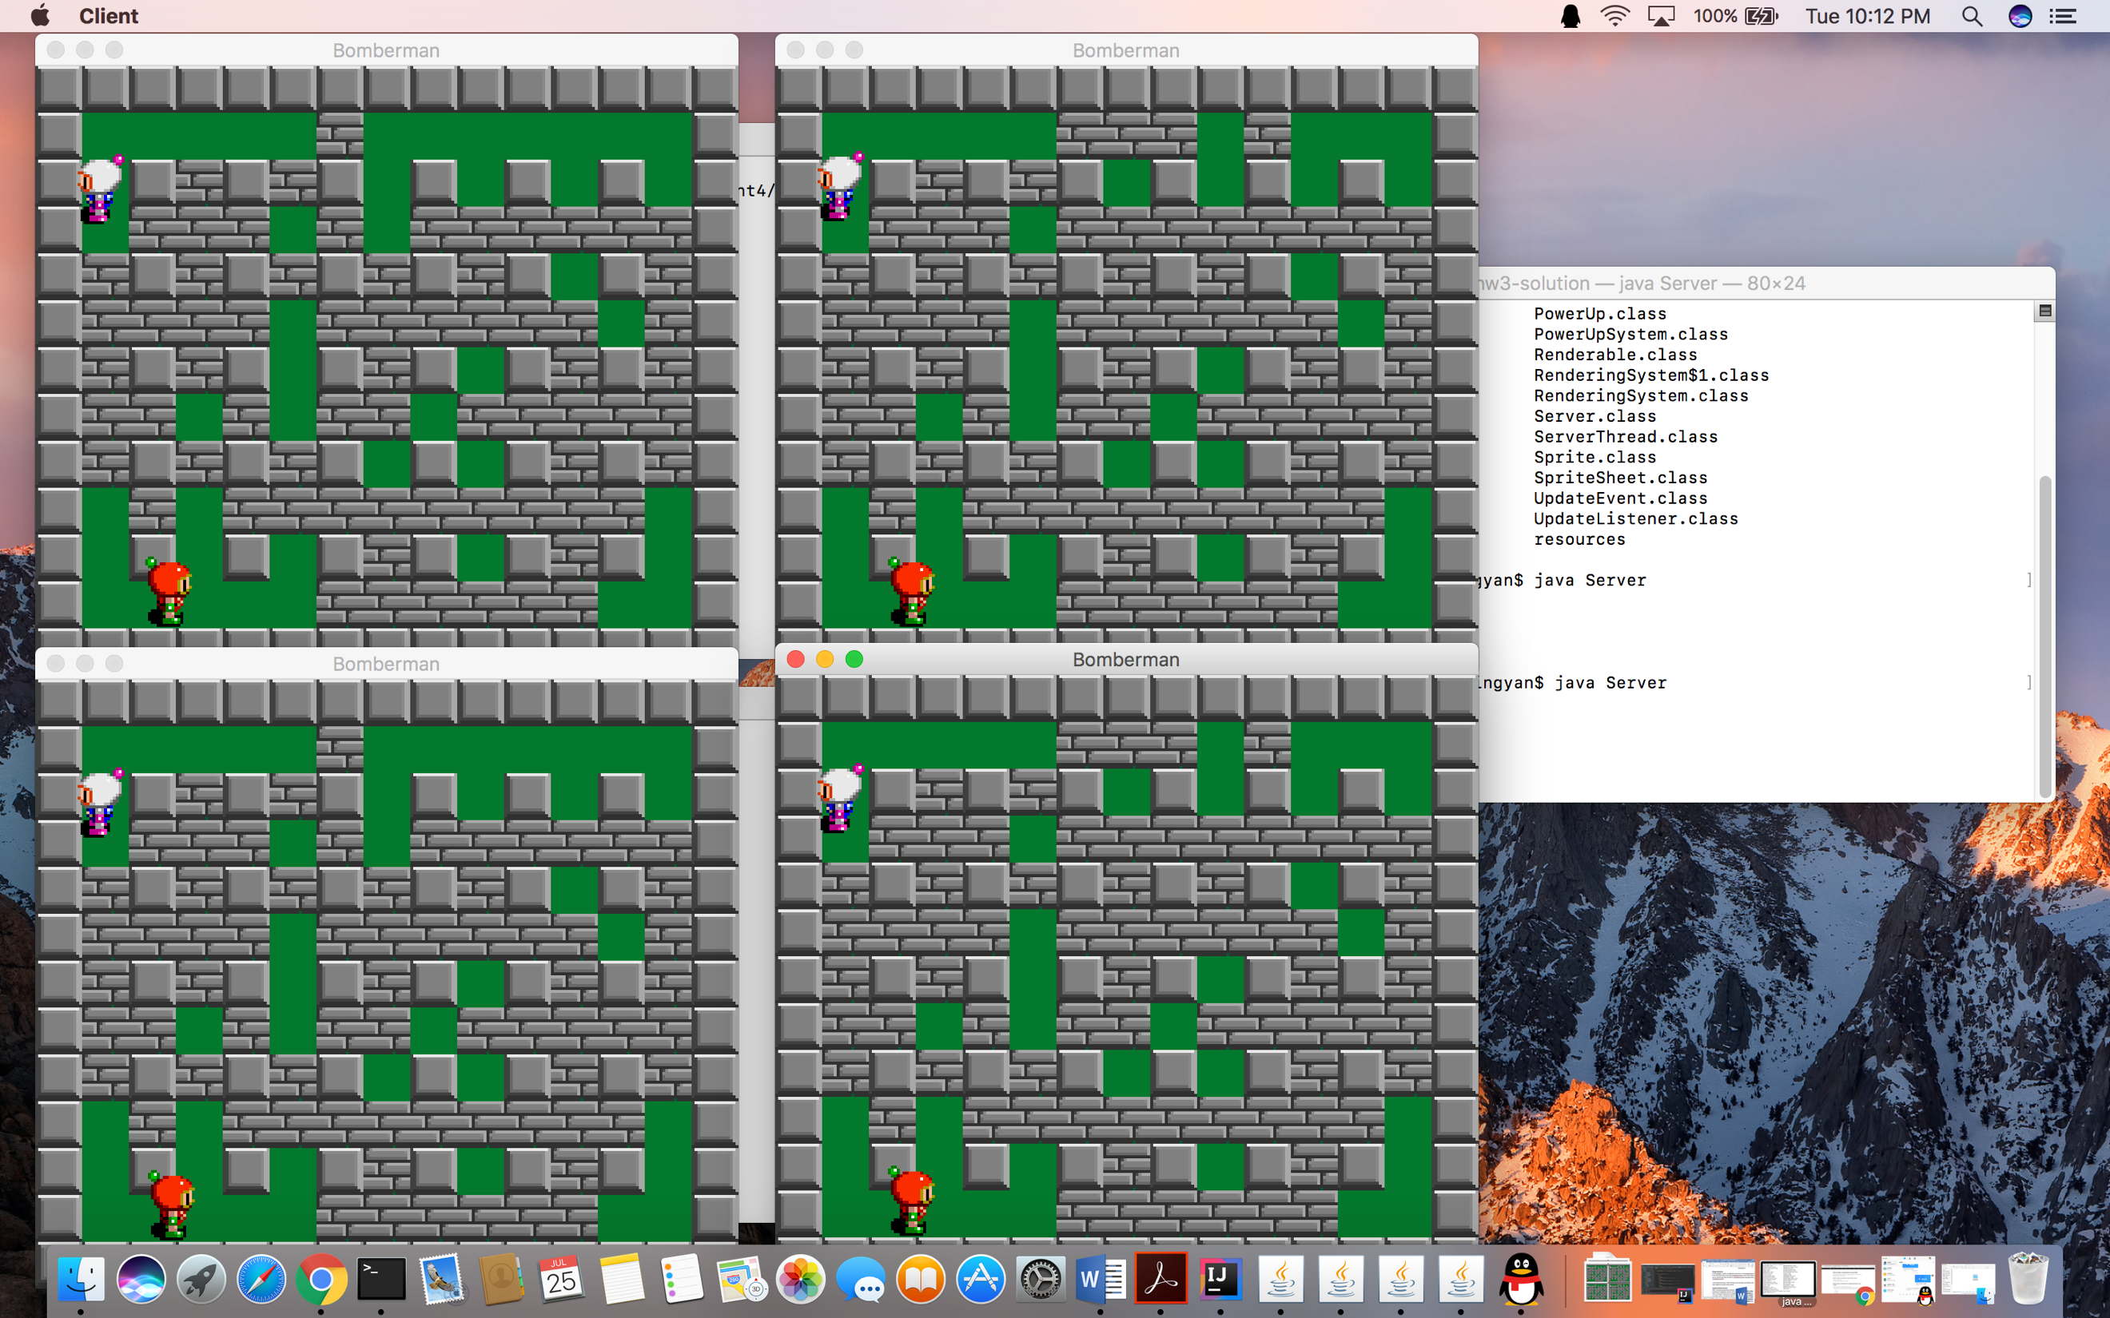

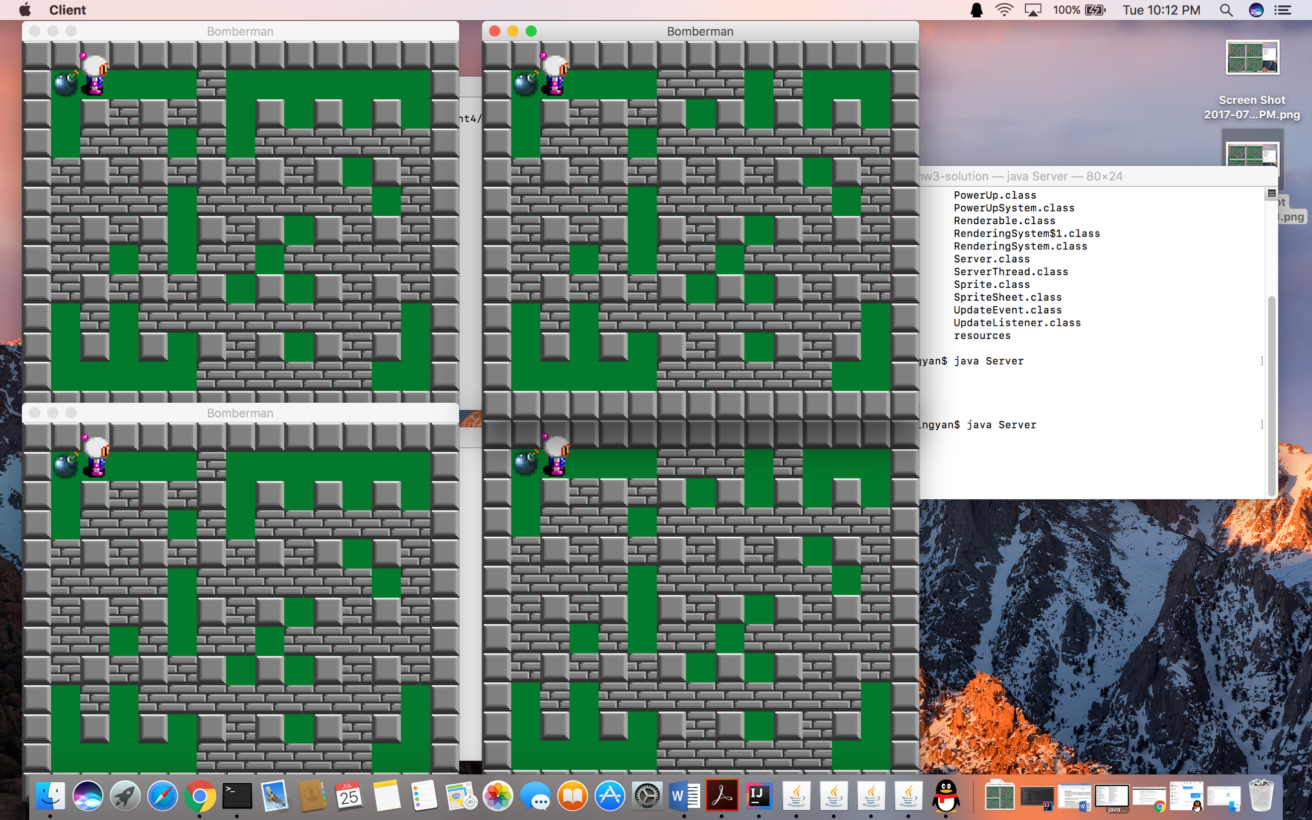

**player dies after the bomb explosion, which is synchronized.**

